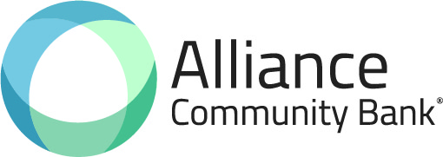

The Wait is Almost Over!

The staff at 1st State Bank of Mason City and Alliance Community Bank are working hard toward our goal of merging our two banks together and operating under the Alliance Community Bank brand. We can’t wait to offer you all of the modern products and services of larger banks while continuing to be a major partner of your local community.

According to our current plan, 1st State Bank of Mason City will run independently until the Friday, October 1, 2021 business day cutoff. We will then work over the weekend to convert your account information to the Alliance Community Bank computer system. We are preparing detailed letters to customers depending on the current products you use that will answer many questions and guide us toward a successful conversion experience together. We also have Frequently Asked Questions (FAQ’s) posted on the Alliance Community Bank website at www.bankacb.com to answer some general questions that may be on your mind.

We can all think back on the sports rivalries between Mason City, Petersburg, and Athens over the years, and those same rivals were the friends that we saw at the fair, attended church with, or shared a cold drink together on a Saturday night. We believe the future of community banking is bringing our local rural communities together and giving back to the same people that allow us to make a living. It is a simple formula that has already proven to be successful beyond our imagination. That’s why our motto is “Community is Our Middle Name”.

Julie and I look forward to welcoming you to Alliance Community Bank this fall.

John L. Leinberger Julie A. Dixon
John L. Leinberger Julie A. Dixon
President/CEO Executive Vice President & Cashier
Alliance Community Bank 1st State Bank of Mason City

